CrudApi

Name : CrudAPi

Revision: 1

Date: 09/18/2020

Author: Rishu Ranjan

For further information please contact:   
  
**Rishu Ranjan**

22rishuranjan@gmail.com

Table of contents

1. Introduction 2

2. Project StRucture 2

3. Project DeTails 3

3.1. CrudAPi 3

3.2. Application 3

3.3. Domain 4

3.4. Persistence 4

4. API information 4

4.1. GET List 4

4.2. GetActivityById 5

4.3. POST Activity 6

4.4. Delete API 7

4.5. Patch API 7

4.6. PUT API 8

# Introduction

Created a CRUD API for activities. This document covers only the backend part.

# Project StRucture

This project contains of 4 layers,

1. **Application** – It is the service layer. It interacts directly with controller, and execute work on its behalf. It is the interface between API and the data layer.
2. **CrudAPI** – It is an API Project. Controller, middleware and services are defined here.
3. **Domain** – Class Project, It contains the model definition.
4. **Persistence** – It implements the entity framework core. Dbcontext and related information is implemented here.

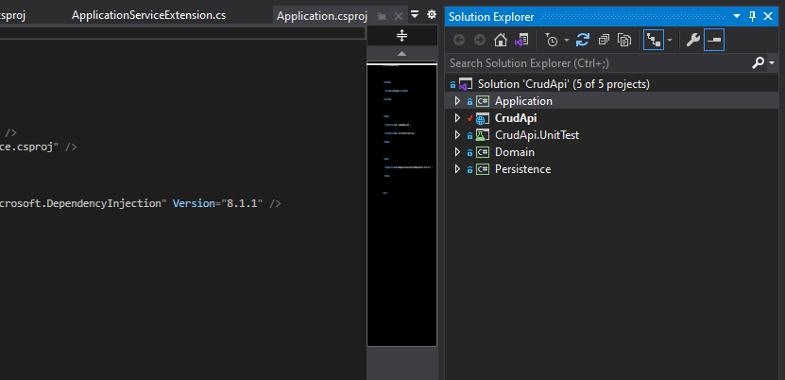

# Project DeTails

## CrudAPi

Folder Structure

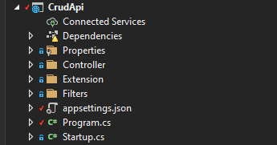

##### Controllers Folder

* 1. Activity Controller
  2. BaseApiContreoller – contains operations common to all API.

b. Extension Folder – *To simplify startup.cs class*

* 1. ApplicationMiddlewareExtenstion – All the middleware services are added here
  2. ApplicationServiceExtension – all the services for dependency injection are added here.

##### c. Filter Folder

a. ValidateModelAttribute – to check the model validation after action execution.

## Application

Methods implemented by Application Service project.

* GetActivities()
* UpdateActivity(Activity act, Guid id)
* PatchActivity(Activity act, Guid id)
* DeleteActivity(Guid id)
* GetActivityById(Guid id)
* AddActivity(Activity act)

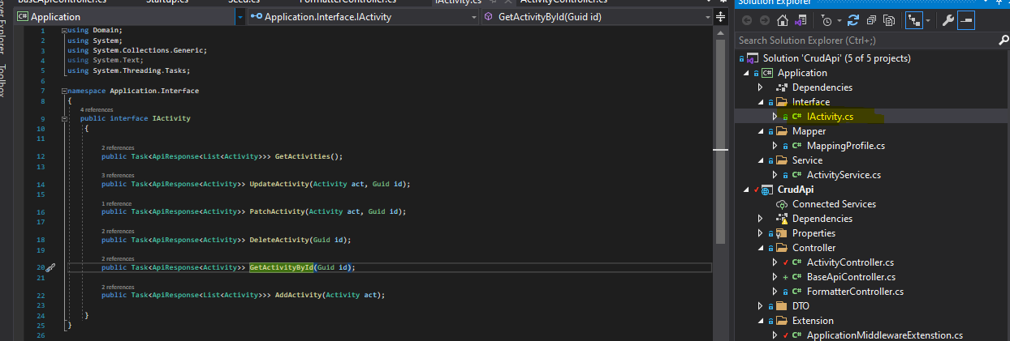

Folder Structure:

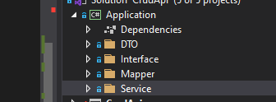

Loosly coupled design, each service class is implement thorough respective interface.

## Domain

Domain project inclued two model class.

1. Activity.cs - model for activity
2. ApiResponse.cs – to handle reponse object from API

## Persistence

This project contains, details about datacontext class and seed.cs class

# API information

## GET List

Endpoint - <http://localhost:5642/api/Activity>

Response Format –

|  |
| --- |
| {      "data": [          {              "id": "25a0f412-25f3-4599-b44f-08d9d731027c",              "title": "Meeting with Adam",              "description": "Sprint Plannig and Retro",              "date": "2021-11-14T13:09:34.4107492",              "category": "business",              "city": "Mumbai",              "venue": "City Center"          },          {              "id": "c96a4c69-44f7-417c-b457-08d9d731027c",              "title": "Brother's birthday",              "description": "send some nice gift",              "date": "2022-08-14T13:09:34.4130395",              "category": "personal",              "city": "Noida",              "venue": "home"          },          {              "id": "2d6e5edc-21da-4afb-b458-08d9d731027c",              "title": "Azure Demo",              "description": "Azure vm, webapp,  functions, Azure Storage, and Azure AD",              "date": "2022-09-14T13:09:34.4130405",              "category": "business",              "city": "Bengaluru",              "venue": "city center"          }      ],      "message": "List fectched!!",      "success": **true**  } |

## GetActivityById

Endpoint - <http://localhost:5642/api/Activity/9e23e5a0-9bcd-4e26-822e-f1a1f26f544b>

Response-

|  |
| --- |
| {      "data": {          "id": "9e23e5a0-9bcd-4e26-822e-f1a1f26f544b",          "title": "Test ",          "description": "Testing post activity from Api",          "date": "2022-09-14T13:09:34.4130405",          "category": "business",          "city": "Bengaluru",          "venue": "city center"      },      "message": "Activity found!!",      "success": **true**  } |

## POST Activity

Endpoint - [http://localhost:5642/api/Activity](http://localhost:5642/api/Activity/2d6e5edc-21da-4afb-b458-08d9d731027c\\)

Body –

|  |
| --- |
| {          "id": "*{{$guid}}*",          "title": "Test ",          "description": "Testing post activity from Api",          "date": "2022-09-14T13:09:34.4130405",          "category": "business",          "city": "Bengaluru",          "venue": "city center"      } |

Response Format –

|  |
| --- |
| {      "data": [          {              "id": "25a0f412-25f3-4599-b44f-08d9d731027c",              "title": "Meeting with Adam",              "description": "Sprint Plannig and Retro",              "date": "2021-11-14T13:09:34.4107492",              "category": "business",              "city": "Mumbai",              "venue": "City Center"          },          {              "id": "c96a4c69-44f7-417c-b457-08d9d731027c",              "title": "Brother's birthday",              "description": "send some nice gift",              "date": "2022-08-14T13:09:34.4130395",              "category": "personal",              "city": "Noida",              "venue": "home"          },          {              "id": "2d6e5edc-21da-4afb-b458-08d9d731027c",              "title": "Azure Demo",              "description": "Azure vm, webapp,  functions, Azure Storage, and Azure AD",              "date": "2022-09-14T13:09:34.4130405",              "category": "business",              "city": "Bengaluru",              "venue": "city center"          },          {              "id": "9e23e5a0-9bcd-4e26-822e-f1a1f26f544b",              "title": "Test ",              "description": "Testing post activity from Api",              "date": "2022-09-14T13:09:34.4130405",              "category": "business",              "city": "Bengaluru",              "venue": "city center"          }      ],      "message": "Success: Acivtity added!",      "success": **true**  } |

## Delete API

Endpoint - <http://localhost:5642/api/Activity/9e23e5a0-9bcd-4e26-822e-f1a1f26f544b>

Response Format –

|  |
| --- |
| {      "data": {          "id": "9e23e5a0-9bcd-4e26-822e-f1a1f26f544b",          "title": "title updated via put",          "description": **null**,          "date": "0001-01-01T00:00:00",          "category": **null**,          "city": **null**,          "venue": **null**      },      "message": "Activity deleted!!",      "success": **true**  } |

## PUT API

Endpoint - <http://localhost:5642/api/Activity/9e23e5a0-9bcd-4e26-822e-f1a1f26f544b>

Body –

|  |
| --- |
| {     "id": "9e23e5a0-9bcd-4e26-822e-f1a1f26f544b",    "title": "title updated via put"   } |

Response Format –

|  |
| --- |
| {      "data": {          "id": "9e23e5a0-9bcd-4e26-822e-f1a1f26f544b",          "title": "title updated via put",          "description": **null**,          "date": "0001-01-01T00:00:00",          "category": **null**,          "city": **null**,          "venue": **null**      },      "message": "Success, Activitity is successfully updated.",      "success": **true**  } |